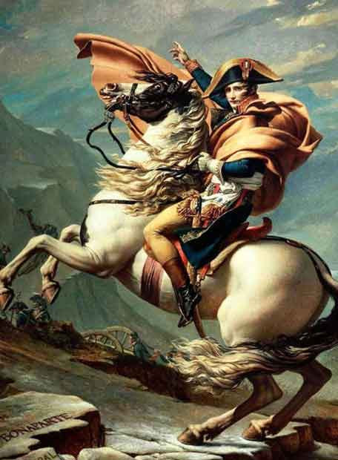
In 1800, Napoleon invaded Lombardy (northern Italy), and fought an Austrian army at Marengo, near Genoa on 14th June . At first, the French were pushed back, but Napoleon managed to rally (regather) his forces, and launched a counter-attack. The entire Austrian army fled. This left Napoleon in control of Northern Italy, and the Austrians made peace with Napoleon in February 1801.
The only enemy left was Britain. Napoleon’s army was ready to invade Britain. However, his fleet was destroyed at the Battle of Trafalgar, south of Cadiz on 21st October 1805. England used this victory to persuade other countries to attack France, and Austria and Russia joined the struggle against Napoleon.
Napoleon dealt with this by invading Austria in November 1805. He captured Vienna before the Austrians could react. He then defeated a combined Russian and Austrian army at the Battle of Austerlitz on 2nd December. Napoleon cleverly tricked the Austrians into attacking him. The French lost 9,000 men, the Allies lost 26,000. The Austrians were completely knocked out of the war.
Napoleon then attacked Prussia (eastern Germany) in 1806. He marched his men 15 miles a day to outmanoeuvre the Prussians, and used his 100,000 man army to win the Battle of Jena near Berlin on 14th October 1806, killing 25,000 Prussians, and capturing another 25,000. The Prussian army had been destroyed. In June the following year, at the Battle of Friedland (Northwest Germany), he destroyed a Russian force which invaded Prussia to try and free the country from French control. The Russians lost 25,000 men killed, and the Russian Tsar (ruler) made peace with Napoleon.
As Napoleon knew that he could not invade Britain, he tried to make them surrender by starving them of trade. He threatened other European countries to stop them trading with the British. However, Portugal refused to obey Napoleon, so he invaded in 1808. The British sent their army to Portugal and Spain, but a stalemate developed. At the Battle of Salamanca (21st July 1812) the British finally managed to gain an advantage, and they destroyed the French armies in Spain at the Battle of Vittoria in June 1813. The British were the first to invade France in the late 1813. Although some historians say that the war in Spain was not important, Napoleon described it as an ‘ulcer’ that drained France of men that he needed to fight elsewhere in Europe.
In 1810, the Austrians formed another army (funded by the by Britain), and tried to free Prussia. However, at Wagram on 4th July 1810 near Vienna, both the French and the Austrians lost 30,000 dead, and the Austrians decided to make peace again. The year 1810 is often seen as the height of Napoleon’s power but the high death toll was starting to cause problems for France, as the dead soldiers had to be replaced.
In June 1812, Russia started trading with the Britain again. Angered by this, Napoleon gathered an army of 450,000 men to conquer Russia. After the inconclusive Battle of Borodino, near Moscow, on 7th September, the French took the city. Napoleon planned it as a base, but the Russians burnt most of it to the ground. As the French retreated to a better base, they were attacked by the Russians, and the brutal winter meant that thousands died from the starvation or the cold them. By the 8th December Napoleon only had 10,000 man left. This inspired other countries to rise up against Napoleon, now that France had been weakened.
In February and March 1813 a new coalition formed, made up of Russia, Prussia, Sweden, and Britain. Although Napoleon gathered 200,000 men, this force was inexperienced. On 16th October the Battle of Leipzig was fought. This was one of the largest battles in history and had a huge death toll with about 60,000 dead on each side. Napoleon was defeated but to escape with most of his army. Although the French fought on over the next few months, they were outnumbered, and the troops were too inexperienced. Napoleon abdicated on 11th April 1814.

